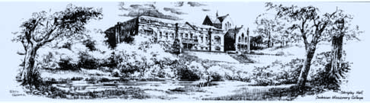Shrigley Old Boys
Reunion 2024
06 – 08 September
THE EVENT
We invite you to book for the Shrigley Old Boys Reunion 2024
Details of the Presentations and Meeting Agenda will be advised when confirmed in August.
As there are bar facilities at Shrigley we will not need a ‘Drinks fund’ but are asking for the £5 voluntary contribution to Savio as they are not charging us for the use of the venue for Sunday Mass and tea/coffee afterwards. Since 2021 we donated £100 to Savio annually
(Please indicate if you are including donation this on the Booking Form)
We have negotiated the best room rates and meal costs at the Hotel. This small increase is understandable as we are living in an ever increasing cost world but the costs are still excellent value for money. Again please book direct see contact details on page 3 of this booking form.
Arrivals can be on Fri evening or Sat morning.
When booking direct for accommodation, ENSURE THAT YOU ADVISE THAT YOU ARE ATTENDING THE SHRIGLEY OLD BOYS REUNION 2024 and indicate on the booking form where staying.
We will be using the bank account of the National Council of Salesian Past Pupils again. Grateful thanks to Pat Howe for arranging. Note that they now use Barclays and the account name has changed. All cheques MUST be made payable to OLD SALESIANS ASSOCIATION(SOB) and sent with the booking form to Bernard O’Neill, 60 Farley Copse, Binfield. Bracknell RG42 1PF. Direct bank transfers may be made to the same account at Barclays sort code 20-66-11;
account no 20026336 quoting refsurname sob24. Confirm on booking form.
So as to assist with our cash flow would appreciate FULL payment as soon as possible, either by cheque or direct payment, and indicate on the booking form.
Please advise if you are able to participate in the concert, see on booking form.
*We will be in touch with you to arrange.

Reunion organised by
Bernard O’Neill: (bernard194720002000@yahoo.co.uk):
*Michael McManus: (michael.mcmanus5@btinternet.com); Gerry Wright: (gerrywright@talktalk.net);
Joe Lomax: (joe@lomax.cc); Keith Dransfield:( keith@its-kd.com)
PROPOSED PROGRAMME SOB 2024
Friday 06 September
Arrive Shrigley
Drinks at the Poachers Inn Bollington after 7pm
Saturday 07 September
Breakfast….
Programme for Sat am (to be arranged)
1230 hrs... lunch
1400 hrs... Tea/coffee in Drawing Room (Sixth form studies)
1430 hrs... Presentation programme
1630 hrs... Free
1800 hrs... Evening 3 course dinner
1930 hrs... Concert/social in Drawing Room
2200 hrs... Goodnight
2215 hrs... Social cont/...

Sunday 08 September
Breakfast….
0930hrs...Commemoration service in Shrigley cemetery
1015hrs... Commemoration service in Bollington cemetery
1100hrs...Mass at Savio followed by tea/coffee/pastries
1300hrs…Lunch at Shrigley

Farewells (SOB 18 reunion)
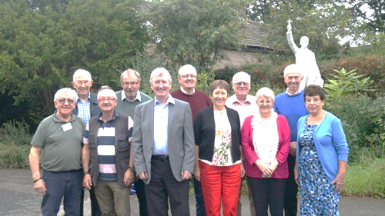

Booking Form SOB 2024
Name. .....................................................................................................................................................
Years at Shrigley.......................................................................................................................................
Address…………………………………………………………………………………………Postal Code………………………………….
Tel No/Mobile…………………………………..E-Mail address………………………………………………………………………….

Date | Venue  Shrigley Hotel | Hollin House | No persons | Cost | Total
Accommodation  (inc Breakfast)  ROOM RATE | Single £88pn  Twin/Double £130pn | £100  £130pn |  | PAY DIRECT for  Accommodation  See Notes below.
MEALS * | Venue | Special Diet |  | Cost
Sat | Shrigley lunch | Yes/No |  | £24-00
Sat | Shrigley supper | Yes/No |  | £36-00
Sun | Shrigley lunch | Yes/No |  | £24-00
 |  |  |  | MEALS | £
 |  | Savio Fund |  | £5 | £
 |  | CHEQUE paid | Yes/NO | TOTAL COST | £
 | Ref:Surname/SOB23 | Direct Bank Payment | Yes/No | Date paid
 |  | CONCERT | YES/NO
Please cross out which is not relevant on the booking form
- Costs of Sat Afternoon suite coffees/teas included in the cost of Shrigley lunch
- Please indicate *Special Diet required …..…………………………………………………………..
- There are 6 rooms either single (£100) or twin/double (£130) rooms at Hollin House in Bollington. Book with Shrigley Hotel
- We have reserved 20 rooms at Shrigley Hotel on a special B/B room rate £130 per night (twin); £88(single) PLEASE BOOK DIRECT TEL : 01625575757 REF:SOB 24
- If staying Friday night at Shrigley, you MUST book evening meal with room booking
- All hotel costs are for your account which must be paid before leaving.
- So as to assist with our cash flow, would appreciate FULL payment with booking form
- We are using a the National Council of Salesian Past Pupils Bank account bank account so please make cheques/payments to OLD SALESIANS ASSOCIATION and direct debits must inc your surname and SOB 24 as reference:
Barclays Bank S/C 20-66-11; A/C No 20026336
- All bookings forms to be sent to Bernard O’Neill;
Email address: bernard194720002000@yahoo.co.uk or post to
Bernard O’Neill 60 Farley Copse Binfield, Bracknell RG42 1PF...ASAP to assist with organising and confirmations.
- All Costs are inclusive of VAT charges

